Shaolin Institute Presents:


Shaolin Chan Foundation ‘s Fund Raising -

Wubin’s Seminar Registration Form

Please PRINT the following information:

Participant Name: ______________________________ Email: ________________________________

Street Address: __________________________________________________________________________________

City: __________________________________________ State: __________________________ Zip: ___________________

Phone: __________________________________

Seminar with Wu Bin featuring the topic Internal KungFu, and Shi Deru featuring topics including Secrets of Ancient Zen Natural Living, Fundamental of Meridian P1 and Healing Arts
Early Registration $39.00 (Feb. 9th)
Registration after Feb 9th $55.00 (after Feb 10th or onsite)
Number of Persons _____ x ____= $_____________

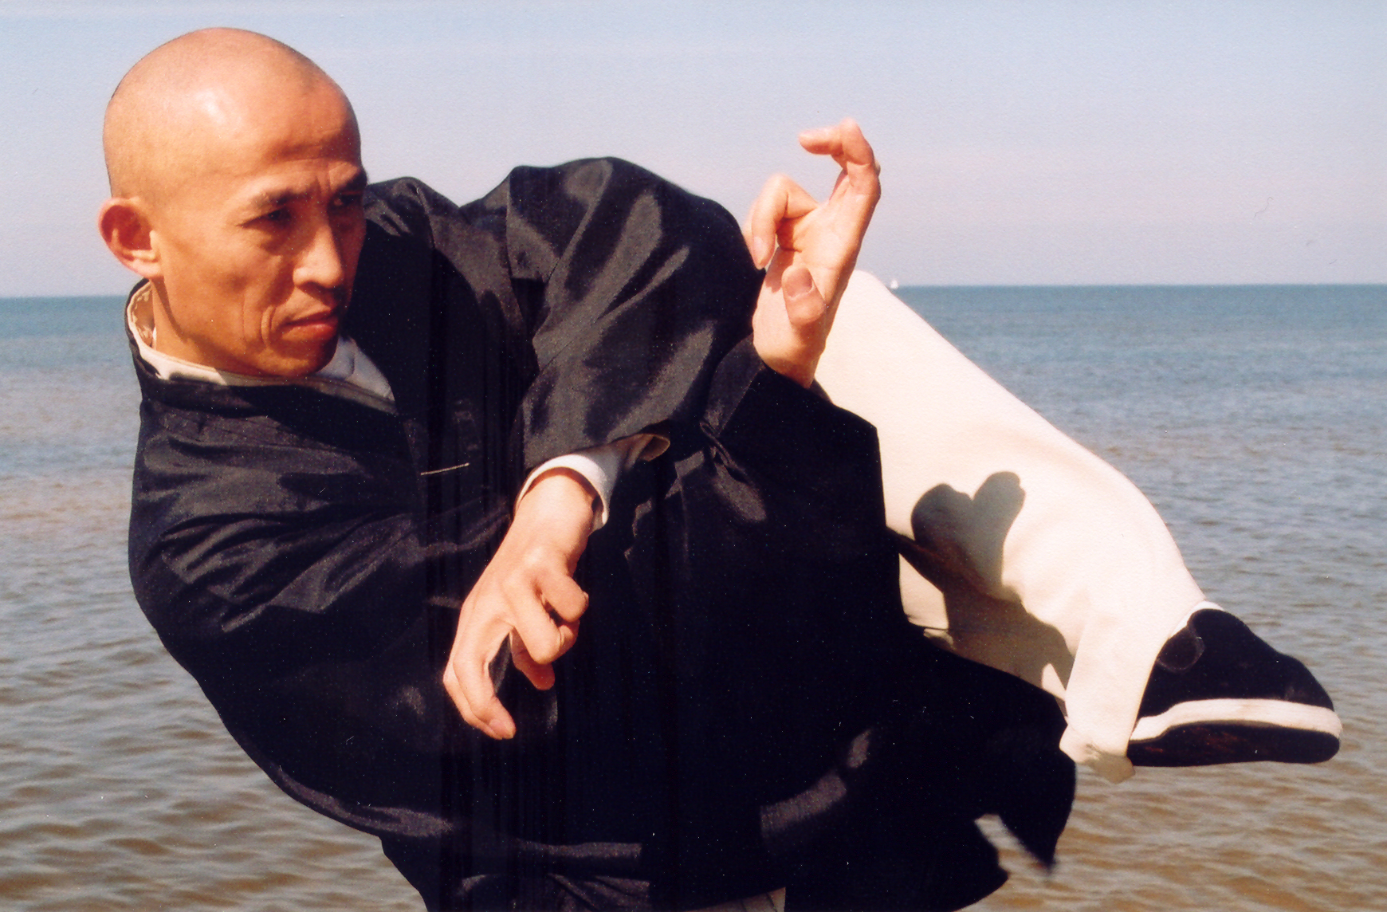
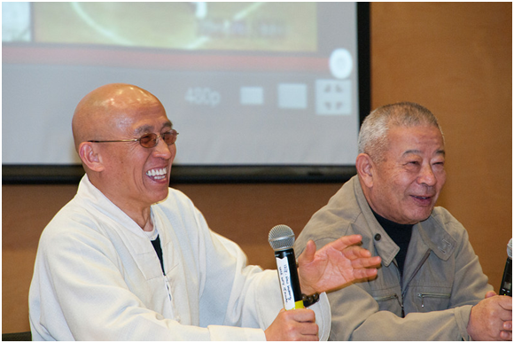

Method of Payment: (Select one)

Visa _____ MC_____ Check #_______ (Make checks payable to: Shaolin Chan Foundation)
(There is a $49 service charge for all returned checks)

Card Number: ________________________________________ Expiration date: ____________________

Signature ____________________________________________ Security Code: ______________________

Cancellation Policy: The registration fee is non-refundable.

Short Term Waivers & Release of Liability
I, the undersigned, knowingly and without duress, do voluntarily submit this form to the Shaolin Institute and Shaolin Chan Foundation, Inc. I do hereby assume all risk of personal, physical, or mental disabilities, injuries or losses, which may result from participating in the Liu Institute International and acting for myself, my heirs, personal representatives, and assignees, I hereby release the said Liu Institute and affiliates, their officers, agents, representatives, servants, employees, and all other related members from all claims, actions, suits, controversies, claims at law or in equity by stand that there is a risk of injury in all activities, and I assume full responsibility for my actions, during and in connection with Shaolin Institute and Shaolin Chan Foundation, Inc.
By signing your name and date below - you indicate that you consent to the Statements of Waiver & Releases of Liability above and that you are at least 18 years of age. For individuals under 18 years of age, a parent must sign in lieu of the minor's consent:
Participant or Parent(s)/Guardian(s)____________________________________________________Date ________________

We, the undersigned Participant, do hereby grant permission to Shaolin Institute and Shaolin Chan Foundation, Inc.
to use my (our) likeness in any video, electronic (web) promotional or educational materials as they see fit..

Participant or Parent(s)/Guardian(s): ___________________________________________________ Date: _______________

The Shaolin Institute and Shaolin Chan Foundation, Inc. reserve the right to cancel any classes at any time due to lack of commitment www.shaolin-world.net.

Wu Bin is the most renowned Wushu Coach in the world. He has produced more champions than any coach in China. Two of his many students stand out the most: the action movie superstar, Jet Li, and Asian action movie star, Wu Jin. He was the technical chairman for Asian Wushu Federation.
DeRu (Shawn Liu) is one of two close indoor disciples of the late great spiritual leader and Great Grand Master Shi SuXi of Shaolin Temple. He has been Kungfu Sanshou technical chairman of Pan America Wushu/Kung Fu Federation since 1995. DeRu was named “The Godfather of Sanshou in America” by International Kung Fu Magazine and “Father of American Sanshou” by Central Chinese TV Networks and other international press. He has trained numerous national and international Kung Fu Sanshou champions in the US. Among them are UFC fighters Patrick Barry and Cung Le.
This will be an unprecedented gathering of Martial Arts & Health and Natural Healing Legends and promises to be an extraordinary experience for any natural health conscious individuals and martial arts fans.

